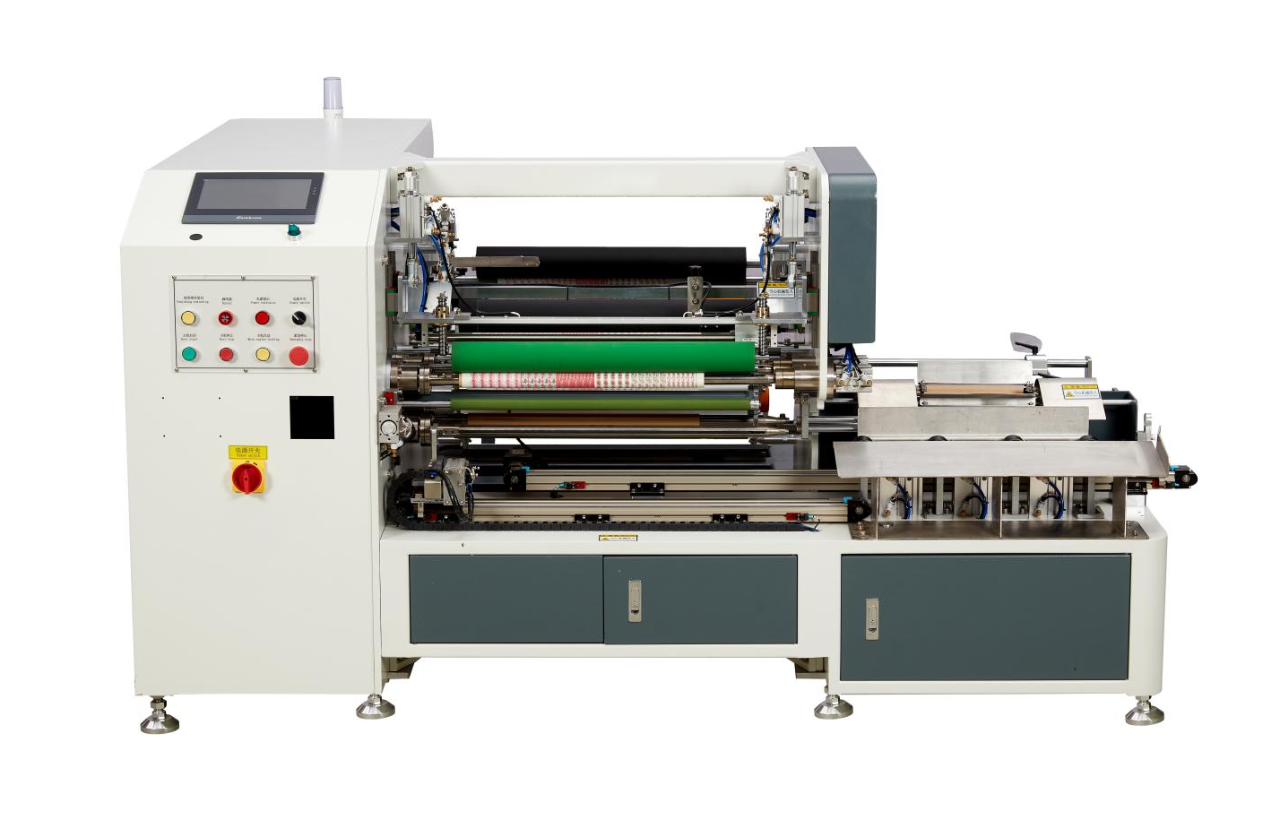
Fully Automatic Tape Rewinder ModelZRF-600
Equipment Layout：
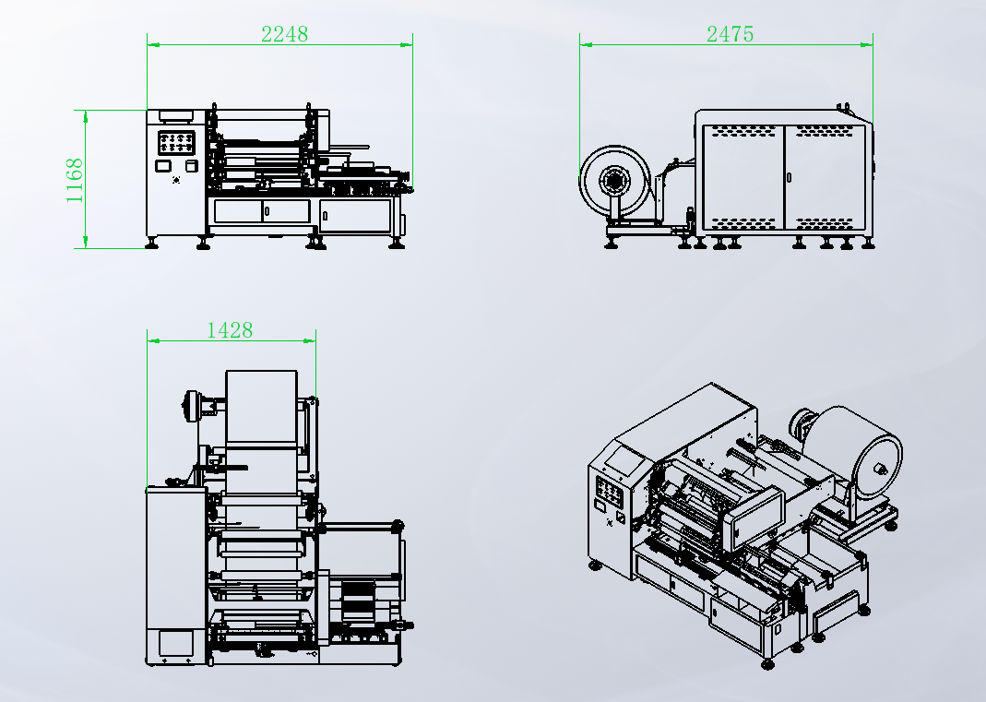
Basic Use：
It is mainly used for laminating and rewinding adhesive tape.

Product characteristics：
- Matsushita PLC is adopted, with servo motor for material feeding and automatic shaft replacement.
- The winding is smooth, the start and stop are stable, and the edge correction is controlled.
- Paper drop, automatic threading, automatic cutting, automatic finishing, automatic discharging,
- Automatic tension unwinding, stable tension and smooth fit. Start and stop the volume smoothly.
- The servo motor pulls the material, and the length is calculated accurately.
- The unwinding adopts manual expansion shaft, which is convenient and fast for loading and unloading.
- Rewind with adhesive surface or peel off the base paper
- Stop when there is no material alarm, material break alarm, no paper tube alarm and bottom paper break alarm.
- One key start, easy operation and unmanned whole process.
- Servo motor torque winding, stable and precise winding tension, exquisite winding, flat end surface.

Main technical parameters：
Model | SHF-600
Paper Core | Customized according to customer requirements
Unwinding Master Roll | Max. Roll Diameter: 550mm
Rewinding Diameter | within 60mm
Rewind Width | Φ（50-600）mm
Production Speed | 6-10pcs/MIN  Subject to rewinding length
Power Supply | 1P220V 50/60HZ/4KW
Air Pressure | 5KG/CM2
Machine Size | 1800*2150*1250mm
Net Weight | 550KG

Configuration parameters：
Model | SHF-600
Touch Screen | MCGSTPC
PLC | MATSUSHITA
Expansion Module | MATSUSHITA
Servo Motor | JINTIAN
Axis Changer Servo Drive | JINTIAN
Servo Motor | SHILIN
Pulling Servo Drive | SHILIN
Winding Servo Motor | SHILIN
Winding Servo Drive | SHILIN
Core Loading Speed Regulating Motor | SANLY
Tail Winding Constant Speed Motor | SANLY
Tension Controller | IMPQCI
Reducer | HASI Mai
Turbine Reducer | WANYU
Edge Corrector | ARISE
Magnetic Powder Clutch | YOSEEN
Magnetic Powder Brake | YOSEEN
Air Switch | CHINT
Switching Power Supply | MINGWEI
Edge Correction Power Supply | MINGWEI
Photoelectric Sensor | DCF
Material Detection Sensor | DCF
Incoming Proximity Switch | CNTD
Discharge Proximity Switch | CNTD
Contactor | SCHNEIDER
Relay | SCHNEIDER
Button Switch | KNDELEK
Tri-color warning light | TAYB
Solenoid Valve | China STNC
Cylinder | STAR
Rodless Cylinder | JIASO
Linear Slide | HIWIN
Magnetic Switch | AIRTAC
Bearing | NSK，HRB
Drive Spindle | Embossed Teflon surface anti-stick treatment
Nip Roll | Silicone lagging (non-adhesive)
Unwind Expanding Shaft | Lug Type Manual Expanding Shaft
Waste Rewind Expanding Shaft | Lug Type Manual Expanding Shaft
Transition Roller | Teflon Coated Knurled Surface Treatment (to prevent material slipping and adhesive sticking)

